**Q 1 CREATING ACCOUNT RESPONSITORY ON GITHUB AND CLONING RESPOSITORY IN GITHUB PAGE .**

STEP 1 : CREATE CCOUNT IN GITHUB .

STEP 2 . CLICK ON NEW

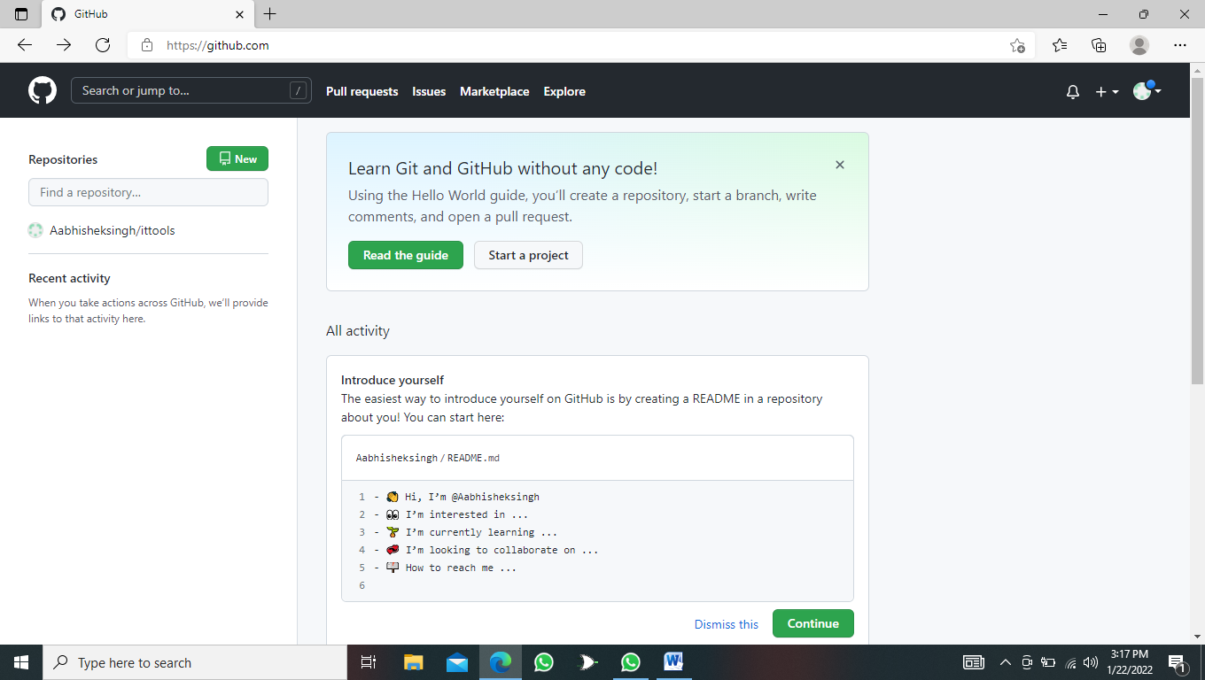

STEP 3: **CLICK PLUSH (+) OPTION AND GO TO NEW REPOTIORY**

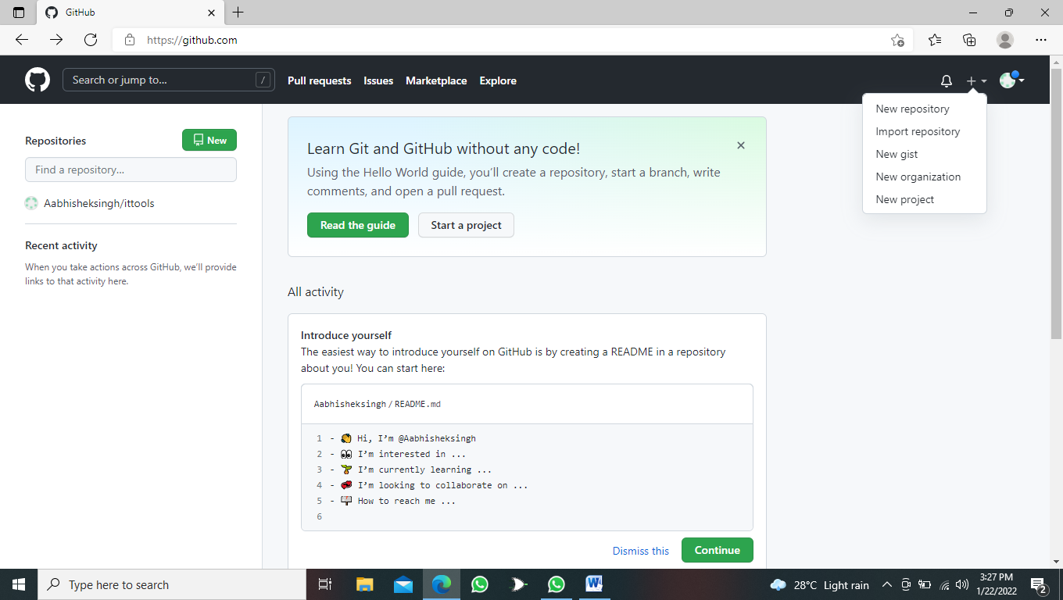

**STEP 4 : ENTER THE Repository name AND CLICK ON CRETE REPOSITORY :**

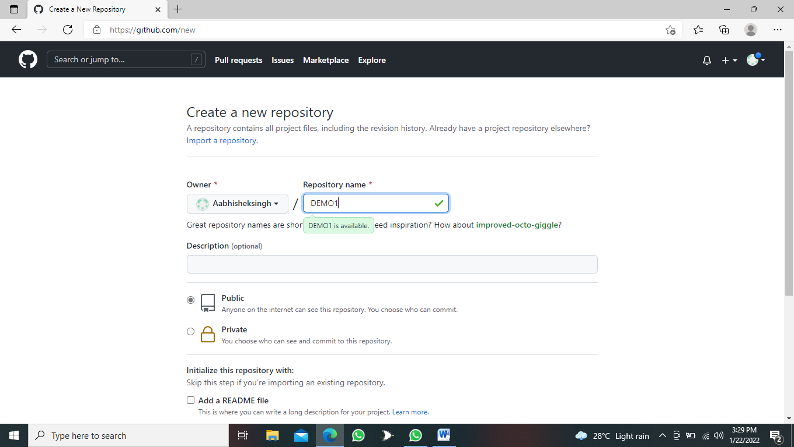

**STEP 5 : COPY THE LINK :**

